import pandas as pd
import numpy as np
import seaborn as sns
import matplotlib.pyplot as plt
import warnings
warnings.filterwarnings(action="ignore")
from sklearn.model_selection import train_test_split
from sklearn.metrics import accuracy_score, classification_report
from sklearn.ensemble import AdaBoostClassifier
from sklearn.neural_network import BernoulliRBM
from sklearn.preprocessing import StandardScaler
from imblearn.over_sampling import SMOTE
import tensorflow as tf
from tensorflow.keras.models import Sequential
from tensorflow.keras.layers import Dense
from sklearn import metrics
from sklearn.metrics import confusion_matrix
from sklearn.datasets import make_classification
from sklearn.metrics import accuracy_score, precision_score, recall_score, f1_score
#importing data from the dataset
df = pd.read_csv(r"C:\Users\agarw\OneDrive\Desktop\Dissertation\data.csv")
#checking for bankrupt companies 0 is non-bankrupt and 1 is bankrupt
bankrupt_data = df['Bankrupt?'].value_counts()
bankrupt_data
0 6599
1 220
Name: Bankrupt?, dtype: int64
#Distribution representation
plt.figure(figsize = (10,5))
ax = sns.countplot(df['Bankrupt?'])
ax.bar_label(ax.containers[0])
plt.title('Class Distribution \n (0:Financially Stable || 1:Financially Unstable)', fontsize = 14)
plt.show()
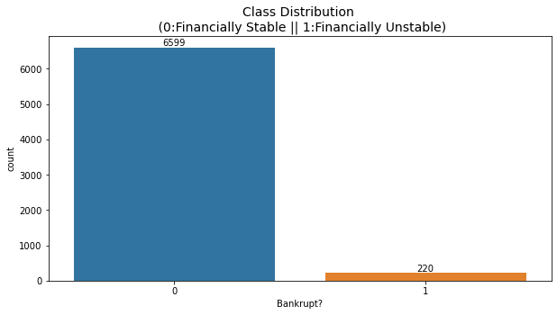
# seperate the Bankrupt label from the dataset
y = df['Bankrupt?']
X = df.drop(['Bankrupt?'], axis = 1)
# divinding our dataset into training dataset
X_train, X_temp, y_train, y_temp = train_test_split(X, y, test_size=0.2, random_state=42)
plt.figure(figsize = (10,5))
ax = sns.countplot(y_train)
ax.bar_label(ax.containers[0])
plt.title('Class Distribution \n (0:Financially Stable || 1:Financially Unstable)', fontsize = 14)
plt.show()
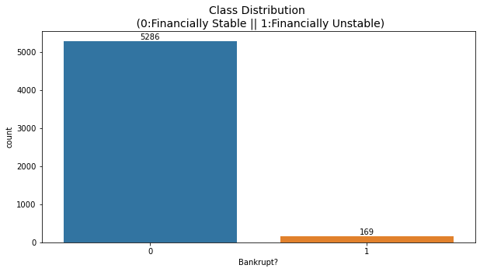
# divinding our dataset into testing and validation
X_val, X_test, y_val, y_test = train_test_split(X_temp, y_temp, test_size=0.5, random_state=42)
# Standardize the data
scaler = StandardScaler()
X_train = scaler.fit_transform(X_train)
X_val = scaler.transform(X_val)
X_test = scaler.transform(X_test)
model = tf.keras.Sequential([
tf.keras.layers.Input(shape=(X_train.shape[1],)),
tf.keras.layers.Dense(64, activation='relu'),
tf.keras.layers.Dense(32, activation='relu'),
tf.keras.layers.Dense(1, activation='sigmoid')
])
model.compile(optimizer='adam', loss='binary_crossentropy', metrics=['accuracy'])
np.shape(X_train)
(5455, 95)
np.shape(y_train)
(5455,)
model.fit(X_train, y_train, epochs=40, batch_size=32, verbose=2)
Epoch 1/40
171/171 - 1s - loss: 0.1816 - accuracy: 0.9553 - 564ms/epoch - 3ms/step
Epoch 2/40
171/171 - 0s - loss: 0.0911 - accuracy: 0.9709 - 152ms/epoch - 888us/step
Epoch 3/40
171/171 - 0s - loss: 0.0796 - accuracy: 0.9725 - 150ms/epoch - 877us/step
Epoch 4/40
171/171 - 0s - loss: 0.0711 - accuracy: 0.9734 - 153ms/epoch - 897us/step
Epoch 5/40
171/171 - 0s - loss: 0.0681 - accuracy: 0.9734 - 160ms/epoch - 936us/step
Epoch 6/40
171/171 - 0s - loss: 0.0638 - accuracy: 0.9756 - 152ms/epoch - 886us/step
Epoch 7/40
171/171 - 0s - loss: 0.0612 - accuracy: 0.9749 - 151ms/epoch - 881us/step
Epoch 8/40
171/171 - 0s - loss: 0.0574 - accuracy: 0.9771 - 156ms/epoch - 911us/step
Epoch 9/40
171/171 - 0s - loss: 0.0543 - accuracy: 0.9778 - 151ms/epoch - 882us/step
Epoch 10/40
171/171 - 0s - loss: 0.0510 - accuracy: 0.9802 - 148ms/epoch - 864us/step
Epoch 11/40
171/171 - 0s - loss: 0.0486 - accuracy: 0.9824 - 149ms/epoch - 873us/step
Epoch 12/40
171/171 - 0s - loss: 0.0450 - accuracy: 0.9822 - 149ms/epoch - 870us/step
Epoch 13/40
171/171 - 0s - loss: 0.0428 - accuracy: 0.9853 - 150ms/epoch - 878us/step
Epoch 14/40
171/171 - 0s - loss: 0.0405 - accuracy: 0.9852 - 148ms/epoch - 867us/step
Epoch 15/40
171/171 - 0s - loss: 0.0381 - accuracy: 0.9870 - 149ms/epoch - 870us/step
Epoch 16/40
171/171 - 0s - loss: 0.0342 - accuracy: 0.9870 - 150ms/epoch - 875us/step
Epoch 17/40
171/171 - 0s - loss: 0.0314 - accuracy: 0.9897 - 149ms/epoch - 872us/step
Epoch 18/40
171/171 - 0s - loss: 0.0286 - accuracy: 0.9907 - 148ms/epoch - 866us/step
Epoch 19/40
171/171 - 0s - loss: 0.0270 - accuracy: 0.9923 - 149ms/epoch - 871us/step
Epoch 20/40
171/171 - 0s - loss: 0.0246 - accuracy: 0.9918 - 149ms/epoch - 872us/step
Epoch 21/40
171/171 - 0s - loss: 0.0241 - accuracy: 0.9927 - 152ms/epoch - 888us/step
Epoch 22/40
171/171 - 0s - loss: 0.0212 - accuracy: 0.9916 - 160ms/epoch - 936us/step
Epoch 23/40
171/171 - 0s - loss: 0.0189 - accuracy: 0.9943 - 148ms/epoch - 863us/step
Epoch 24/40
171/171 - 0s - loss: 0.0208 - accuracy: 0.9932 - 151ms/epoch - 884us/step
Epoch 25/40
171/171 - 0s - loss: 0.0197 - accuracy: 0.9934 - 150ms/epoch - 879us/step
Epoch 26/40
171/171 - 0s - loss: 0.0143 - accuracy: 0.9954 - 152ms/epoch - 889us/step
Epoch 27/40
171/171 - 0s - loss: 0.0138 - accuracy: 0.9954 - 150ms/epoch - 877us/step
Epoch 28/40
171/171 - 0s - loss: 0.0107 - accuracy: 0.9976 - 149ms/epoch - 869us/step
Epoch 29/40
171/171 - 0s - loss: 0.0093 - accuracy: 0.9974 - 155ms/epoch - 904us/step
Epoch 30/40
171/171 - 0s - loss: 0.0085 - accuracy: 0.9978 - 156ms/epoch - 915us/step
Epoch 31/40
171/171 - 0s - loss: 0.0077 - accuracy: 0.9980 - 153ms/epoch - 896us/step
Epoch 32/40
171/171 - 0s - loss: 0.0076 - accuracy: 0.9976 - 149ms/epoch - 874us/step
Epoch 33/40
171/171 - 0s - loss: 0.0058 - accuracy: 0.9991 - 154ms/epoch - 900us/step
Epoch 34/40
171/171 - 0s - loss: 0.0059 - accuracy: 0.9991 - 150ms/epoch - 875us/step
Epoch 35/40
171/171 - 0s - loss: 0.0042 - accuracy: 0.9995 - 151ms/epoch - 885us/step
Epoch 36/40
171/171 - 0s - loss: 0.0168 - accuracy: 0.9927 - 150ms/epoch - 878us/step
Epoch 37/40
171/171 - 0s - loss: 0.0104 - accuracy: 0.9974 - 151ms/epoch - 881us/step
Epoch 38/40
171/171 - 0s - loss: 0.0047 - accuracy: 0.9995 - 153ms/epoch - 894us/step
Epoch 39/40
171/171 - 0s - loss: 0.0031 - accuracy: 0.9995 - 166ms/epoch - 968us/step
Epoch 40/40
171/171 - 0s - loss: 0.0027 - accuracy: 0.9998 - 151ms/epoch - 885us/step
<keras.src.callbacks.History at 0x1c073ba60a0>
#Validation dataset
y_val_pred = (model.predict(X_val) > 0.5).astype(int)
22/22 [==============================] - 0s 754us/step
# Evaluate the model's performance on the validation set
val_accuracy = accuracy_score(y_val, y_val_pred)
precision = precision_score(y_val, y_val_pred)
recall = recall_score(y_val, y_val_pred)
f1_value = f1_score(y_val, y_val_pred)
val_report = classification_report(y_val, y_val_pred)
print("Accuracy", val_accuracy)
print("Precision", precision)
print("Recall", recall)
print("F1 Score", f1_value)
print("Validation Classification Report:\n", val_report)
Accuracy 0.9633431085043989
Precision 0.391304347826087
Recall 0.45
F1 Score 0.4186046511627907
Validation Classification Report:
precision recall f1-score support
0 0.98 0.98 0.98 662
1 0.39 0.45 0.42 20
accuracy 0.96 682
macro avg 0.69 0.71 0.70 682
weighted avg 0.97 0.96 0.96 682
conf_matrix = confusion_matrix(y_val, y_val_pred)
print("Confusion Matrix")
print(conf_matrix)
Confusion Matrix
[[648 14]
[ 11 9]]
y_test_pred = (model.predict(X_test) > 0.5).astype(int)
22/22 [==============================] - 0s 740us/step
# Evaluate the model's performance on the test set
test_accuracy = accuracy_score(y_test, y_test_pred)
precision = precision_score(y_test, y_test_pred)
recall = recall_score(y_test, y_test_pred)
f1_value = f1_score(y_test, y_test_pred)
test_report = classification_report(y_test, y_test_pred)
print("Accuracy", test_accuracy)
print("Precision", precision)
print("Recall", recall)
print("F1 Score", f1_value)
print("Test Classification Report:\n", test_report)
Accuracy 0.9516129032258065
Precision 0.45454545454545453
Recall 0.3225806451612903
F1 Score 0.3773584905660377
Test Classification Report:
precision recall f1-score support
0 0.97 0.98 0.97 651
1 0.45 0.32 0.38 31
accuracy 0.95 682
macro avg 0.71 0.65 0.68 682
weighted avg 0.94 0.95 0.95 682
conf_matrix = confusion_matrix(y_val, y_test_pred)
print("Confusion Matrix")
print(conf_matrix)
Confusion Matrix
[[640 22]
[ 20 0]]

